To save an GIF image with a transparent background
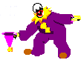
- Mask the image unwanted area
- Click File  Save as.
- 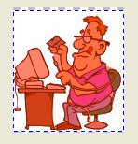
- Type a filename in the Filename box.
- Choose where you want to save the image.
- Choose the GIF file format from the Save as type list box.
- Click Save.
- In the Convert to paletted dialog box, customize the color palette and settings.
For best results, choose None from the Dithering list box and Websafe from the Palette list box.
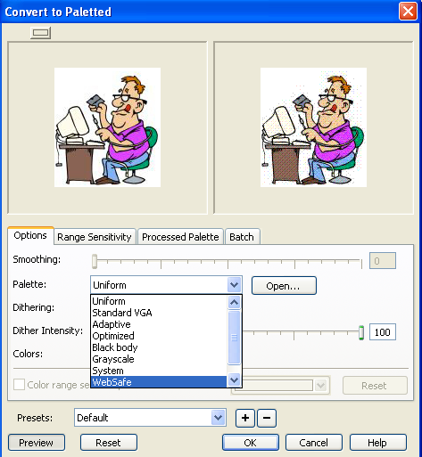
- Click OK.
- In the GIF export dialog box, enable one of the following options:
  - Image color — makes the color you click on the color palette transparent
  - Masked area — makes the protected area of your image transparent
  - 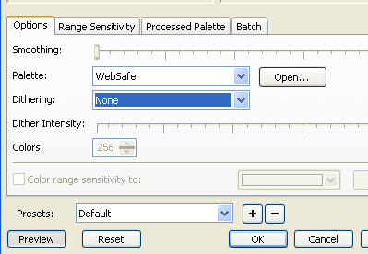
If you want to make the editable area of an image transparent, click the Invert mask check box.
You can also
Sample a colour from the image to make transparent | In the GIF export dialog box, click the Eyedropper tool , and in the first preview window, click the background colour.
Load the image into a Web browser as an interlaced GIF | Click the Interlace image check box.
Preview the transparent area of the image | Click Preview. The transparent background displays as a chequered area. Masked areas that are transparent display as a solid colour.
- If you are saving an image that contains more than 256 colors, you must convert it to Paletted color mode to decrease the number of colors in the image. For more information, see "Changing the color mode of images."

Related Topics
- Creating images with transparent backgrounds

